Information Requirements

Study

OLA Consolidated Report Format with Summary and Conclusion

2013

Contents

1. Summary 4

2. Expected SOLUTION and its Benefits 5

2.1 Introduction 5

2.2 The organizations situation and initial conditions 5

2.2.1 Tasks 5

2.2.2 Current Business Solutions 5

2.3 The IRS method used 5

2.3.1 IRS 5

2.3.2 Interviews 6

2.3.3 Consolidation of the interview reports 7

2.4 Other source material 7

3. Functional areA information needs 8

3.1 Executive level 8

3.1.1 The business objectives 8

3.1.2 Need of improved information 8

3.1.3 Potential improvement of the foundation for decision-making 8

3.1.4 Expected benefits from improvements 8

3.2 Department 1 8

3.2.1 Products 8

3.2.2 Objective 8

3.2.3 The results and the result quality (client needs satisfied) of the departments activity 8

3.2.4 Suggested procedure improvements and their benefits 8

3.3 Department 2 8

3.3.1 Products 8

3.3.2 Objective 8

3.3.3 The results and the result quality (client needs satisfied) of the departments activity 8

3.3.4 Suggested procedure improvements and their benefits 8

3.4 Department nn 8

4. SOLUTION requirements 9

4.1 General system requirements 9

4.2 information system Modules 9

4.3 Module 1 9

4.3.1 Business Case 1 9

4.3.2 Business Case 2 9

4.3.3 Business Case nn 9

4.4 Module 2 9

4.4.1 Business Case 1 9

4.4.2 Business Case 2 9

4.4.3 Business Case nn 9

4.5 Module NN 9

4.5.1 Business Case 1 9

4.5.2 Business Case 2 9

4.5.3 Business Case nn 9

5. Conclusion and recommendations 10

5.1 Cost/benefit analysis 10

5.1.1 Calculation of benefits without autocorrelation 10

5.1.2 Estimation of solution implementation costs 10

5.2 Recommended Information systems and their Priority 10

5.3 suggested implementation project 10

5.3.1 Important phases and milestones 10

Attachment 1 Critical success factors 11

Attachment 2 Object lifecycle matrices (CRUD) 12

Attachment 3 Object Descriptions 13

Attachment 4 Input-output tables 14

Attachment 5 Vocabulary 15

Attachment 6 Key figures 16

1. Department 1 16

2. Department 1 16

3. Department n 16

Attachment 7 ERD user guide 17

Figure 1 Echelon structure with FHOSP 13

Figure 2 ERD with Action and Structure Objects 16

# Summary

# Expected SOLUTION and its Benefits

## Introduction

## The organizations situation and initial conditions

### Tasks

### Current Business Solutions

## The IRS method used

The method used to prepare this requirements specification is IRS.

### IRS

IRS comprises the following activities:

* Establishment of Study scenario
* Definition of sections (virtual organization that encompass all DHS tasks)
* Selection of participants (Facilitator, Workgroup, Reference Group, Section interview participants, …)
* IRS Introduction to participants.
* Interviews with section participants.
* Documentation of task based sectional information requirements
* Review and approval of section IRS reports
* Management level Interviews and IRS management report writing, review, and approval
* Consolidation workshop with IRS Workgroup and IRS Reference group to write this report
* IRS result sign off by sponsor.

The IRS has been done on 3 organizational levels.

1. **Sections**
2. **Departmental managers**
3. **Executive Managers**

### Interviews

Each interview has the following participants:

* Interviewers (project manager and facilitator)
* A person from the IRS reference group
* Selected persons from section or management level.

We have established sectional reports with the following content:

* Tasks, products, and objective
* Why the tasks are performed in the context of DHS
* Information used
* Information not available that could improve section performance
* Information exchange with others
* Possible improvements of current systems and procedures
* Improvements of current systems and procedures from integration of systems
* Potential benefits from improved systems, procedures, and integration
* Suggested solutions (not required).

We have established departmental reports:

* Department responsibility and tasks
  + Who are the primary “clients”?
  + Who are the primary “vendors”?
* The results and the result quality (client needs satisfied) of the departments activity
* Expected and required quality of the departments products
* Need of improved information
* Potential improvement of decision foundation
* Expected benefits from improvements.

We have established one executive level report

* The business objectives of DHS
* Need of improved information
* Potential improvement of the foundation for decision-making
* Expected benefits from improvements.

### Consolidation of the interview reports

The conclusions in the interview reports are coordinated on a workshop with the IRS Workgroup and the IRS Reference group.

This report is the result of the IRS interviews and the IRS consolidation workshop.

## Other source material

# Functional areA information needs

IRS has been conducted within the following organization structure:

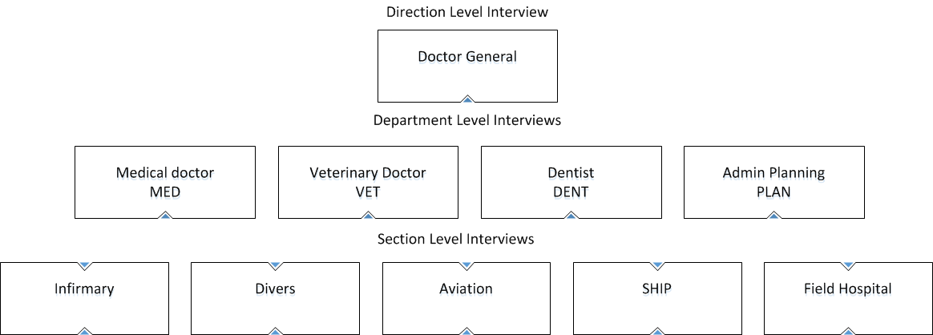

## Executive level

### The business objectives

### Need of improved information

### Potential improvement of the foundation for decision-making

### Expected benefits from improvements

## Department 1

### Products

### Objective

### The results and the result quality (client needs satisfied) of the departments activity

### Suggested procedure improvements and their benefits

## Department 2

### Products

### Objective

### The results and the result quality (client needs satisfied) of the departments activity

### Suggested procedure improvements and their benefits

…

## Department nn

# SOLUTION requirements

This consolidated IRS report does not only describe the requirements to an IT based solution, it also describes the requirements for better business workflows (use cases).

## General system requirements

## information system Modules

For each module, selected parts of the overall information model will be presented to illustrate the objects used in the module.

## Module 1

Pertinent information model in Entity Relationship (ER) Diagram.

### Business Case 1

Dataflow Diagrams (DFD) as needed

Workflow documentation as needed

### Business Case 2

…

### Business Case nn

## Module 2

Pertinent information model in ER Diagram.

### Business Case 1

### Business Case 2

…

### Business Case nn

…

## Module NN

Pertinent information model in ER Diagram.

### Business Case 1

### Business Case 2

…

### Business Case nn

# Conclusion and recommendations

## Cost/benefit analysis

### Calculation of benefits without autocorrelation

|  |  |
| --- | --- |
| **Benefits** | **Value €/year** |
| Maintenance of current systems | 40,000 |
| … | 150,000 |
| … | 150,000 |
| … | 40,000 |
| **Total €/year** | **5000,000** |

### Estimation of solution implementation costs

|  |  |
| --- | --- |
| **Investment** | **€** |
| Purchase of COTS | 800,000 |
| Implementation of workflows and reports | 1000,000 |
| Implementation of requirements in COTS | 300,000 |
| … | 150,000 |
| … | 150,000 |
| **Total** | **3250,000** |

|  |  |
| --- | --- |
| **Annual costs** | **€** |
| … | … |
| **Total** | **1000,000** |

## Recommended Information systems and their Priority

## suggested implementation project

### Important phases and milestones

##### Critical success factors

##### Object lifecycle matrices (CRUD)

##### Object Descriptions

##### Input-output tables

Here is shown the total interchange of information between business functions and between business functions and external organizations as this was documented in the sectional reports; incl. the information maintained in each section’s functions.

**Table over information to and from Business Functions**

|  |  |  |  |  |
| --- | --- | --- | --- | --- |
| **T0**  **FROM** | **FUNC1** | **FUNC2** | **FUNC3** | **…FUNCn** |
| **FUNC1** |  |  |  |  |
| **FUNC2** |  |  |  |  |
| **FUNC3** |  |  |  |  |
| **…FUNCn** |  |  |  |  |

##### Vocabulary

|  |  |  |
| --- | --- | --- |
| **Acronym**  **Concept** | **Definition** | **Example** |
|  |  |  |
|  |  |  |
|  |  |  |
|  |  |  |
|  |  |  |
|  |  |  |
|  |  |  |
| … | … | … |

##### Key figures

###### Department 1

###### Department 1

…

###### Department n

##### ERD user guide